**CSC2021 Advanced Programming using C# and C++**

**CSC2022 Games Programming using C# and C++**

**Sprint 1:**

**Backlog**

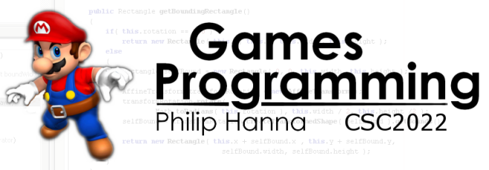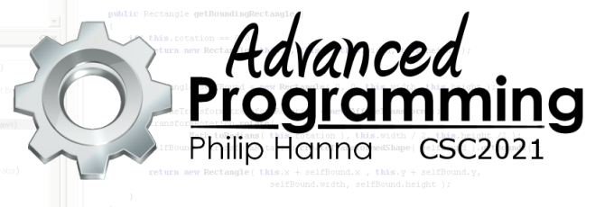

|  |
| --- |
| User Story 1: Game Loop |
| As a developer I can control how frequently my game is updated and drawn so that I can develop across a wide range of devices |
| Develop a game loop that will attempt to provide a developer specified number of UPS and FPS. |

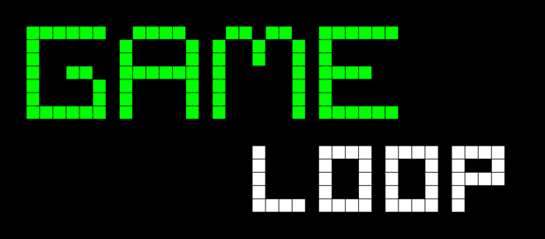



|  |
| --- |
| User Story 2: Asset Manager |
| As a developer I can make use of an asset manager to load, store and share my game assets so that my game objects have a single point of contact for all their asset needs. |
| Develop an asset manager that is capable of loading in graphical assets (samples provided). The asset manager should store the assets in a map data structure. The manager should offer methods that enable game objects to access the stored assets.  Optional: the asset manager should be able to load a list of assets. It could also be able to discard from memory loaded assets that are no longer needed. |



|  |
| --- |
| User Story 3: Asset Displayer |
| As a developer I can use a tool to view on screen the assets I have loaded so that I can visually browse my loaded assets. |
| Develop a screen that will rotate through the images stored within the asset manager. Each asset should be displayed on the screen for a short period of time before fading out (decreasing alpha value) and being replaced by a fade in (increasing alpha) of the next stored image. |

|  |
| --- |
| User Story 4: Thumb Control |
| As a player I can use two digits to control the movement of two onscreen images so that I can practice control of onscreen movement. |
| Develop an app that provides two circular thumb control regions. Touch events within the control region will move a corresponding image. The direction from the centre of the control region to the touch event will determine the direction of movement. The distance from the centre of the control region to the touch event determines the speed of movement. Two control regions should be provided, one for each thumb. Each control region should control the movement of one on-screen entity (assets provided). |

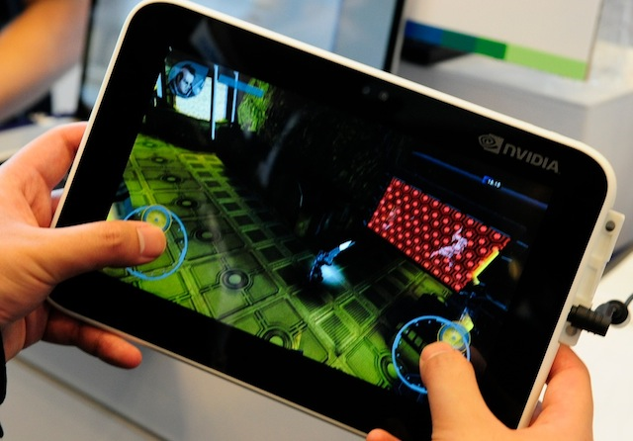

|  |
| --- |
| User Story 5: Transforming Graphics |
| As a user I can control the facing and size of a spaceship as it flies around the screen so that the visual impact is increased. |
| Develop further your multi-touch demo so that the controlled objects are two spaceships (asset provided). The spaceship image should be transformed so that it points in the direction of movement. The spaceship image should also be scaled in size so that as it moves faster its size decreases. |

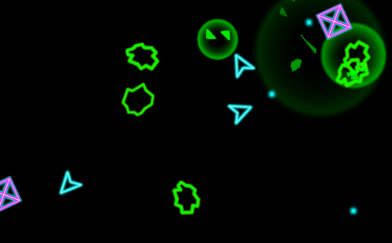



|  |
| --- |
| User Story 6: Sound and Music |
| As a developer I can load and play sound effects and streaming music to enrich the quality of the game. |
| Extend the developed asset manager so that it can support sound and music objects. Produce a demo in which background music is streamed and the playback of more than one sound effect can be triggered by the user. |

|  |
| --- |
| User Story 7: Viewports |
| As a developer I can specify a layer and screen viewport so that I can determine the region of my game world that is displayed to the player. |
| Develop further your multi-touch demo so that the controlled objects move about within a space that is wider than the screen (background image provided) with a viewport determining the region that is displayed on the screen.  Optional: Use a split screen approach with a separate viewport for each controlled object. |

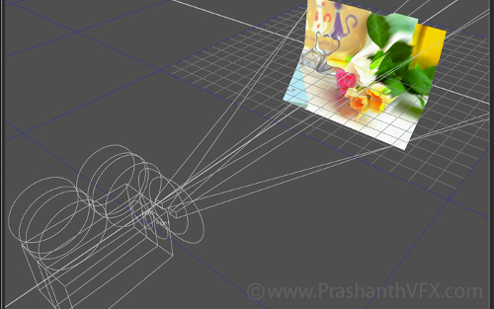

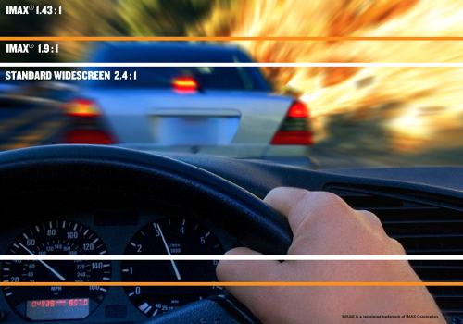

|  |
| --- |
| User Story 8: Aspect Ratios |
| As a developer I can easily configure the viewport to take into account the aspect ratio so that I can easily deploy my game across a range of devices. |
| Extend the multi-touch demo so that it works across a range of different screen aspects. |